React Apps – Exercises
Exercises and homework assignments for “Full Stack Apps with AI” course at SoftUni.

Weather Forecast
In a new workspace, create a Vite React app to show the weather forecast by city:
- Use flow: enter a city -> click [Search] -> display forecast
- Use this free weather API: https://open-meteo.com
- Visualize the current weather and a forecast for the next few days
- Use icons to visualize weather conditions

Sample AI Prompt
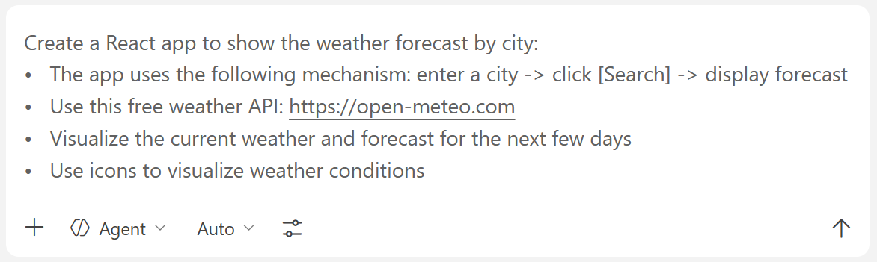

The App in the Browser
Here is how the app looks when a city is searched for:
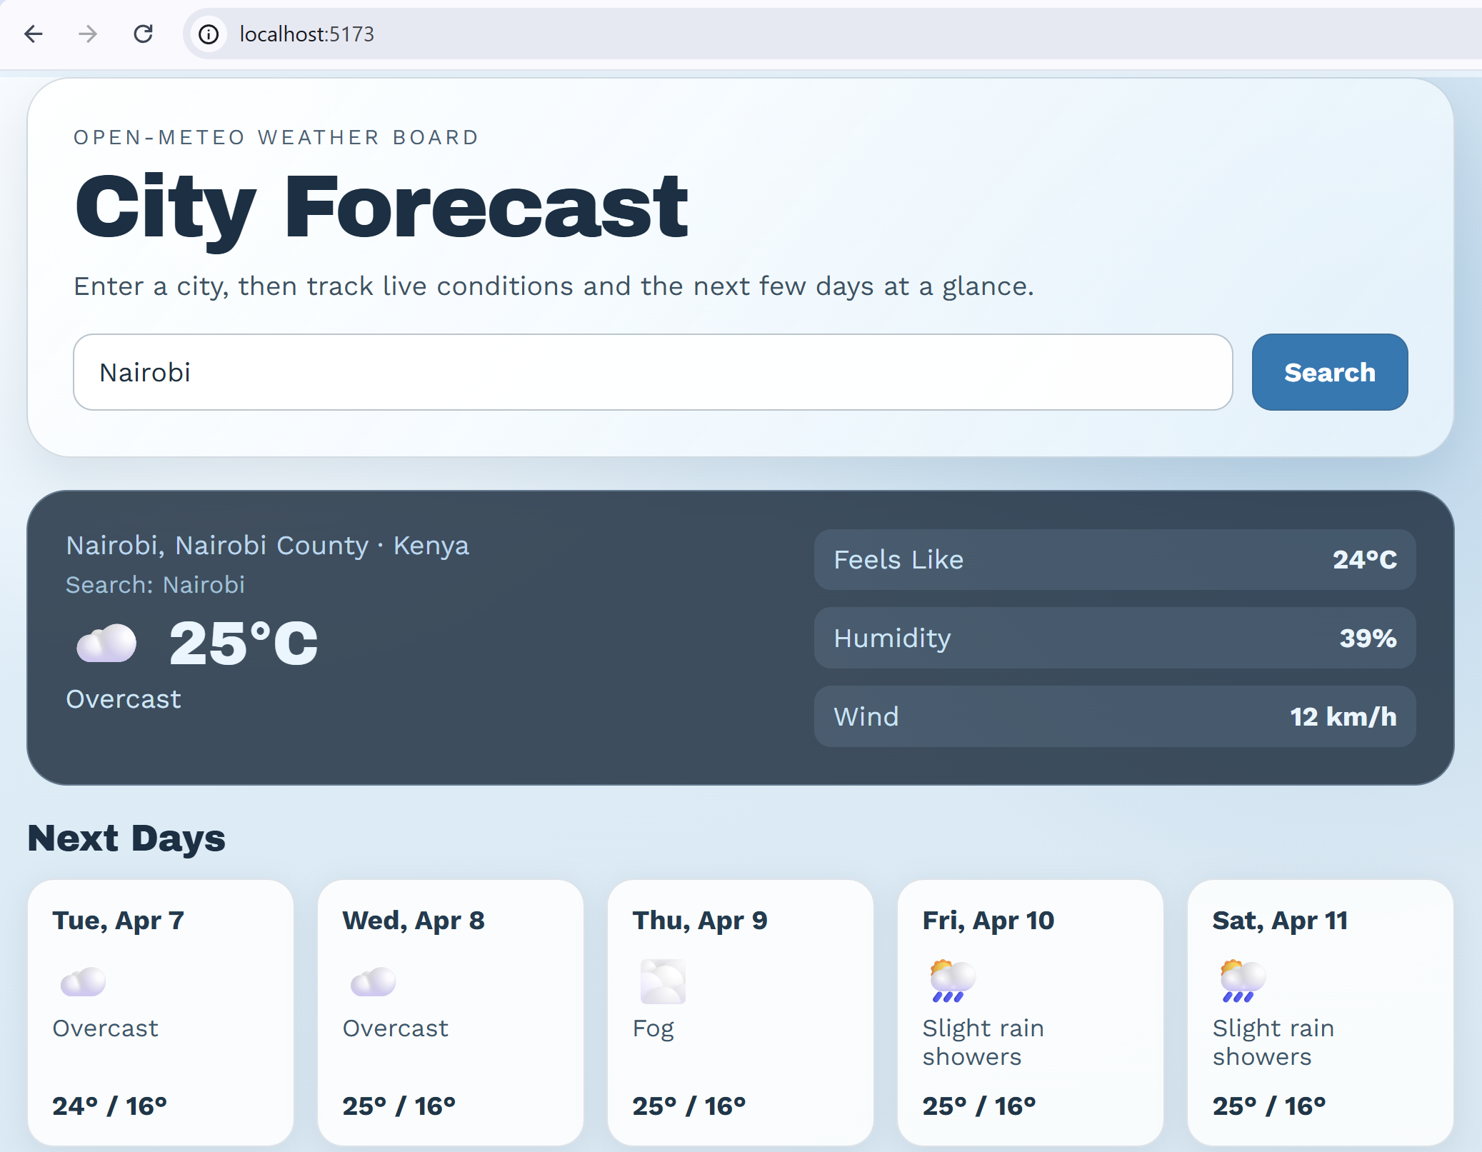

Multi-Page Company Website
In a new workspace using React, TypeScript, Vite and React Router, create a simple web site with pages and navigation:
- Site topic: choose your own, e.g. construction company / healthcare clinic / yoga studio / other
- Site structure:
  - / -> Home component
  - /services -> Services component
  - /news -> News component
  - /news/:id -> NewsItem component
  - /about -> About component
  - /contacts -> Contacts component
- Implement site navigation bar with links to the pages
- Implement modern, responsive UI, with icons, UI transitions and effects
- Keep the news data in the JS code (later it should be moved to a database)
- Generate SEO-friendly news slugs (semantic text-based URL segments that identify each news item)
- Use React Router to implement the app layout, pages and navigation.

Sample AI Prompt
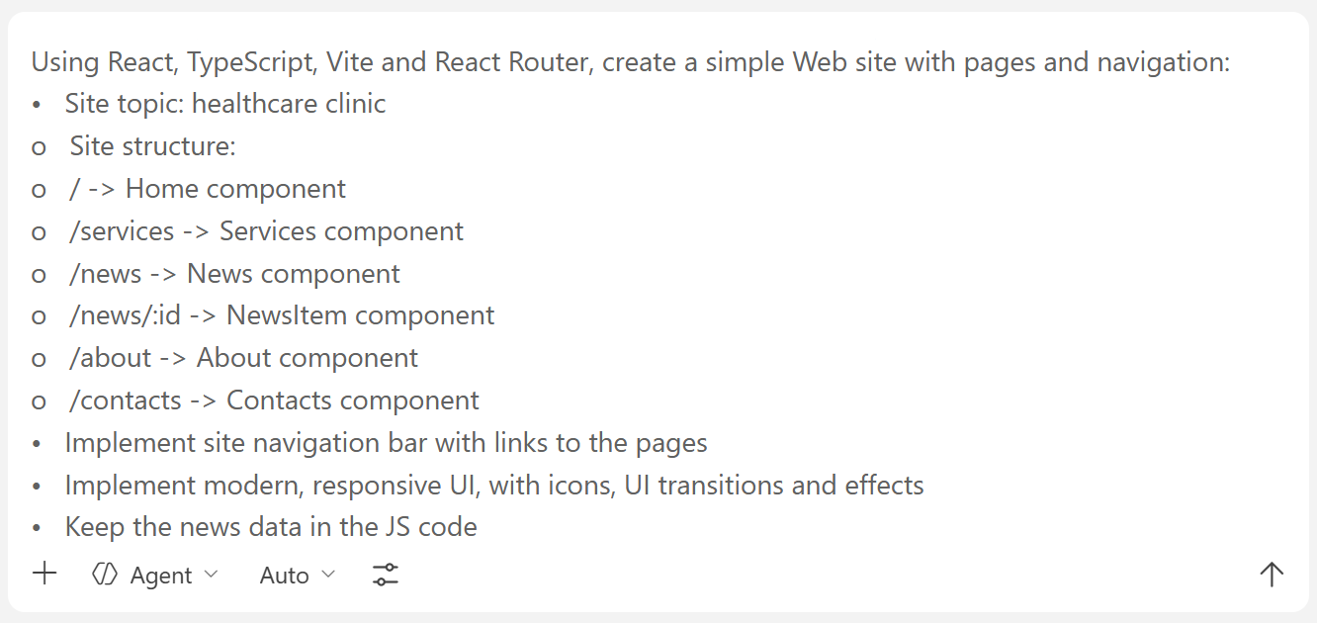

Sample Result
This is an example of how the generated React app may look like:
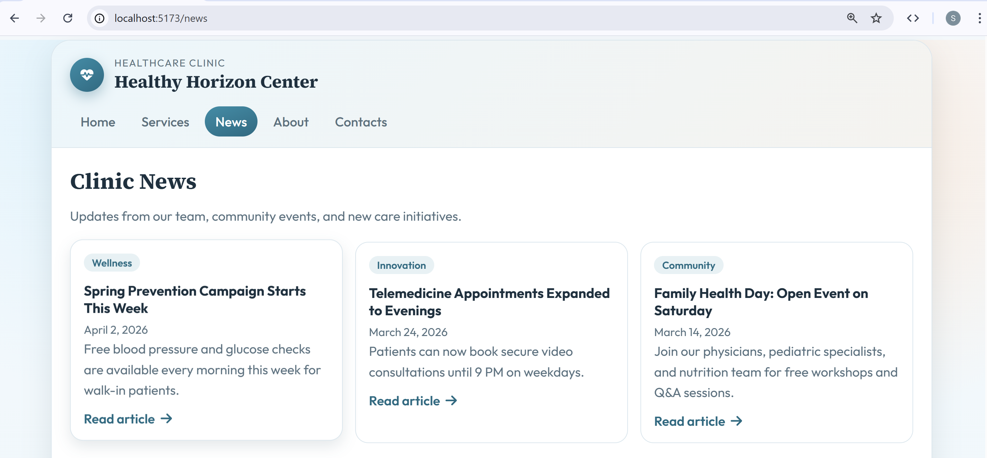
News page uses SEO-friendly (semantic) URLs, which improve the UX:
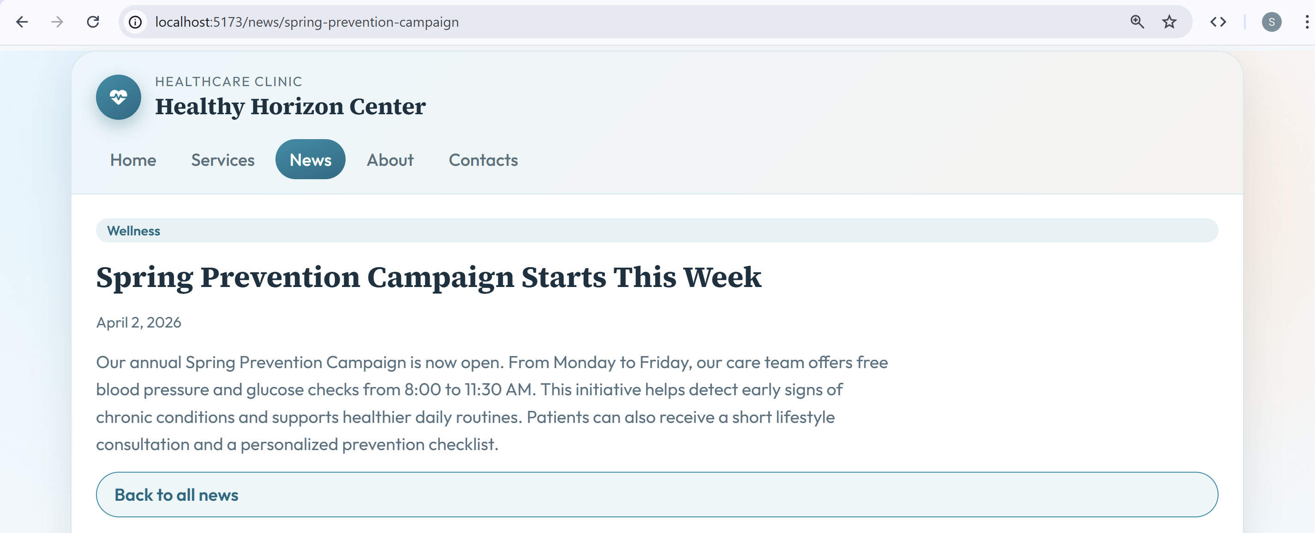

The Code in VS Code
Look at the AI-generated code, explore the React pages and component, their structure and composition.
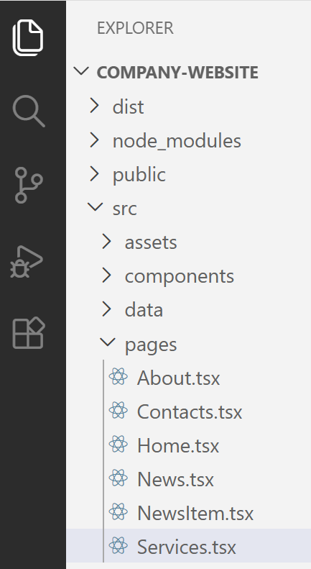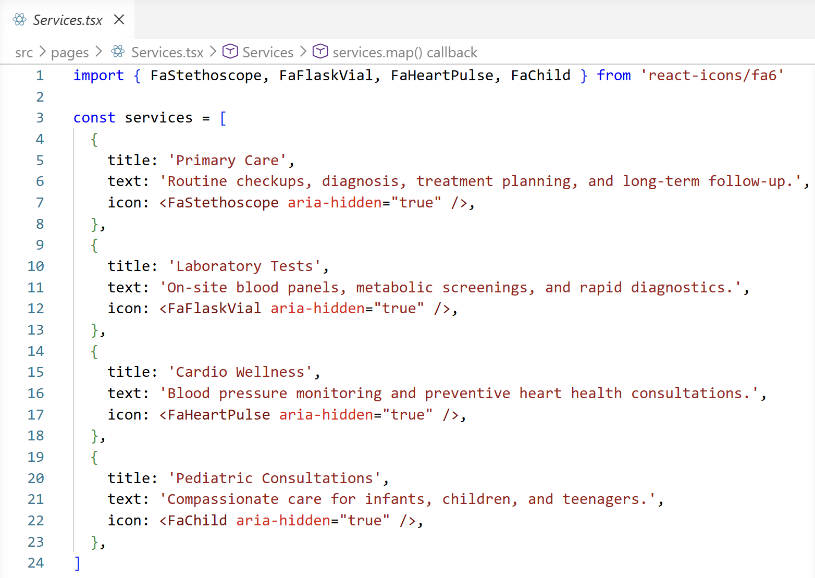

E-Commerce Product Catalog
In this exercise we shall implement a simple product catalog browser with React, Vite, TypeScript, Tailwind, React Router and Supabase. This is a simple front-end app with Supabase back-end, just a browser, without users and authentication. We shall build the app step by step, with multiple prompts, with a review of the produced result after each prompt.

Step 0. Create a VS Code Workspace
Create a new workspace in Visual Studio Code for your app, e.g. `React-Catalog`.
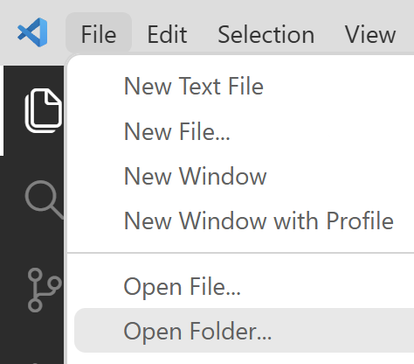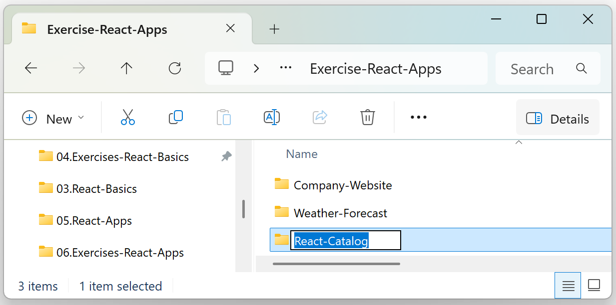
Select the folder which was just created:
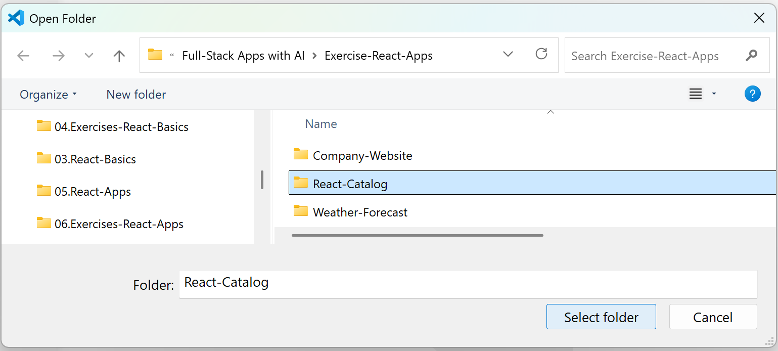

Step 1: Setup Vite + React + Tailwind + React Router
Initialize a React app with Vite, TypeScript, Tailwind and React Router. Don't use templates. Instead create the app structure and config files from scratch.

Sample AI Prompt
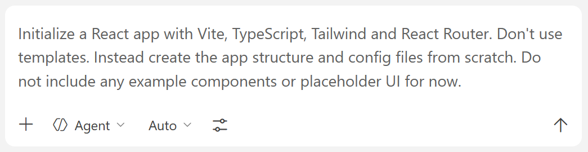

The Result
Copilot has generated basic empty files, which will be filled with content in the next step:
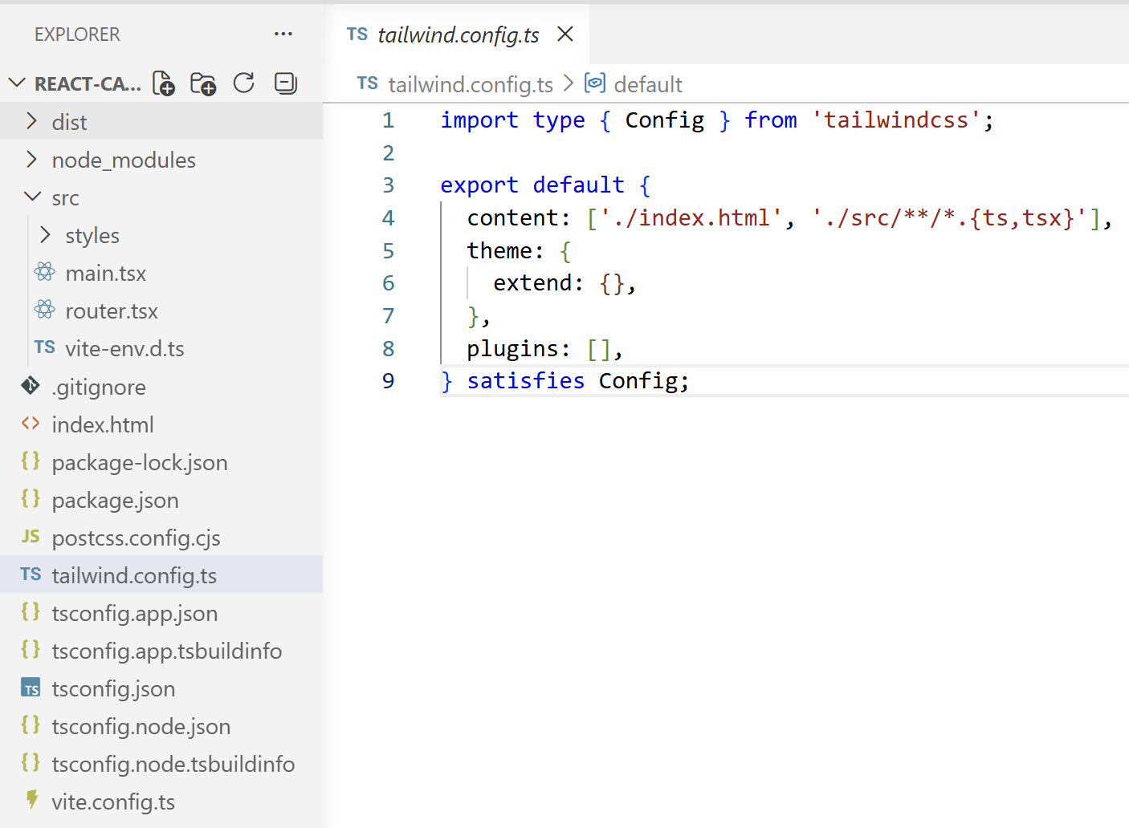

Step 2: App Pages
- Initialize the app structure, layout, pages and navigation.
- Configure React Router with three pages: Home (/), Catalog (/products), and Product Details (/product/:id).
- Implement empty app pages and navigation between them.
- Build a shared Navbar layout and a reusable ProductCard component.

Sample AI Prompt
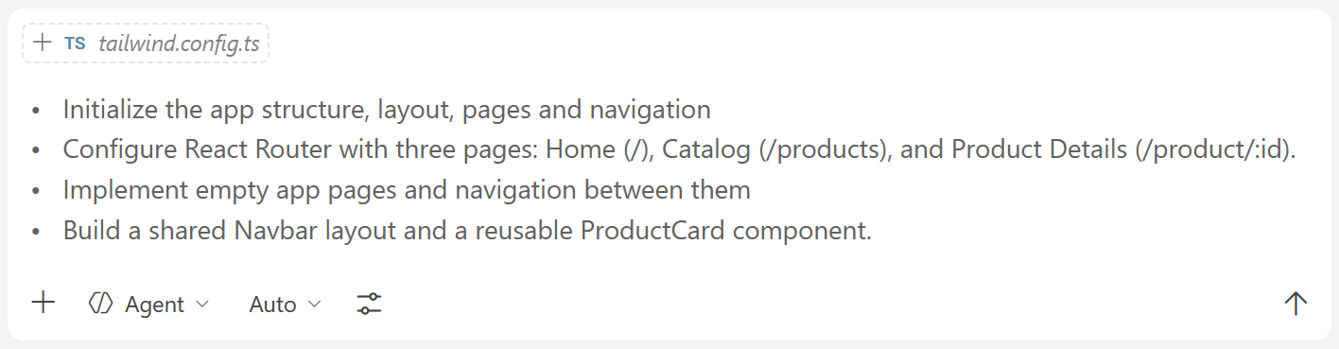

The Result
Ensure that the app layout, pages and navigation are implemented and work correctly.
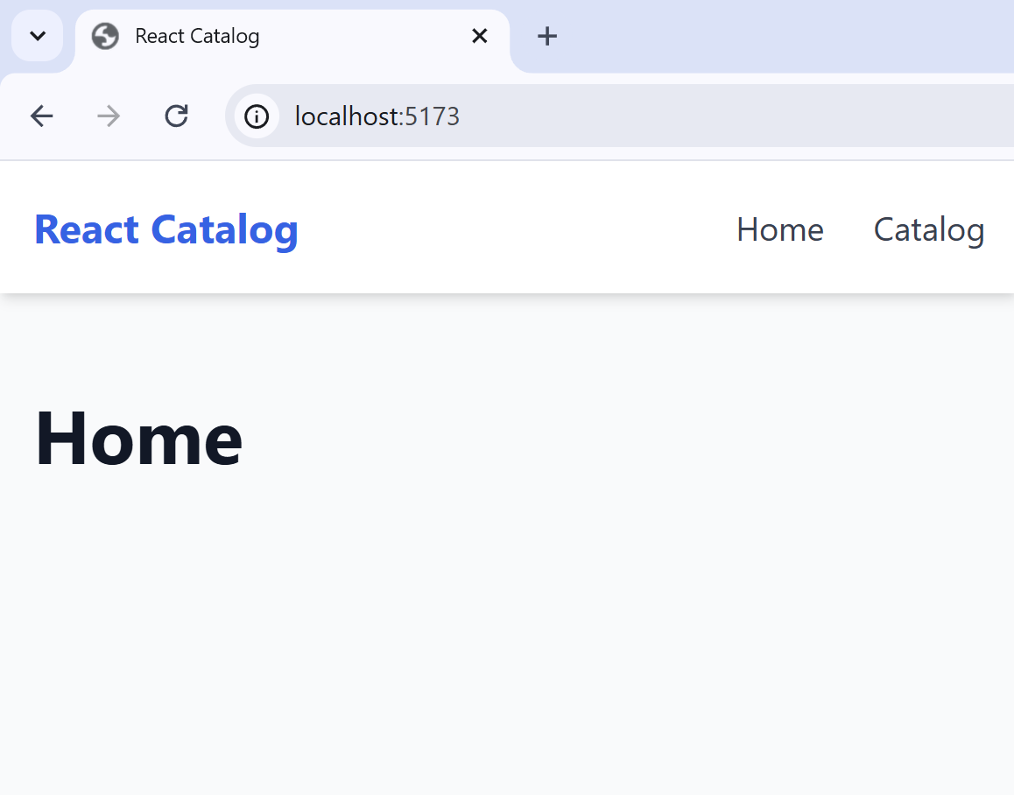

Step 3: Supabase DB
- Setup a Supabase project and connect it with VS Code using Supabase MCP.
- Create the `products` table in the DB
  - Products should hold id, title, description, price, photo URL.
  - Some products are featured (will be shown on the home page).
- Keep it simple: no auth and users, simple RLS policies.
- Insert 20 sample products into the DB.
- Use Supabase migrations, keep migrations code in a local folder.

Create a Supabase Project
Sign in Supabase and go to your Dashboard. Choose (or create) an organization, then go to Projects and create a new project for the app:
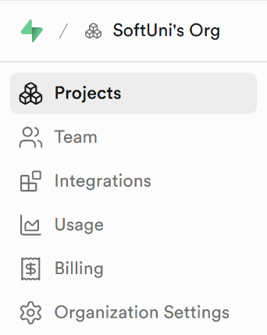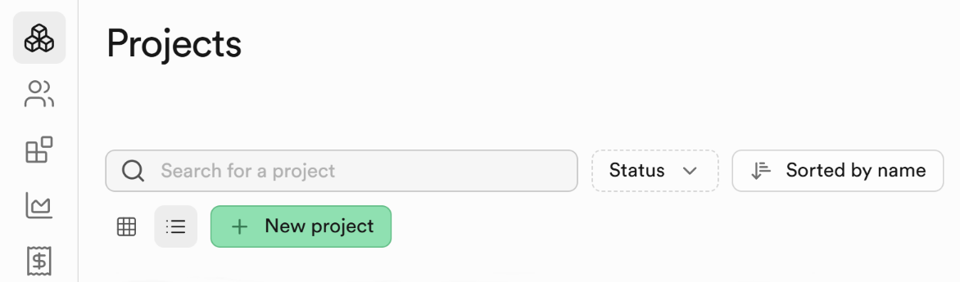
Fill in the necessary details:
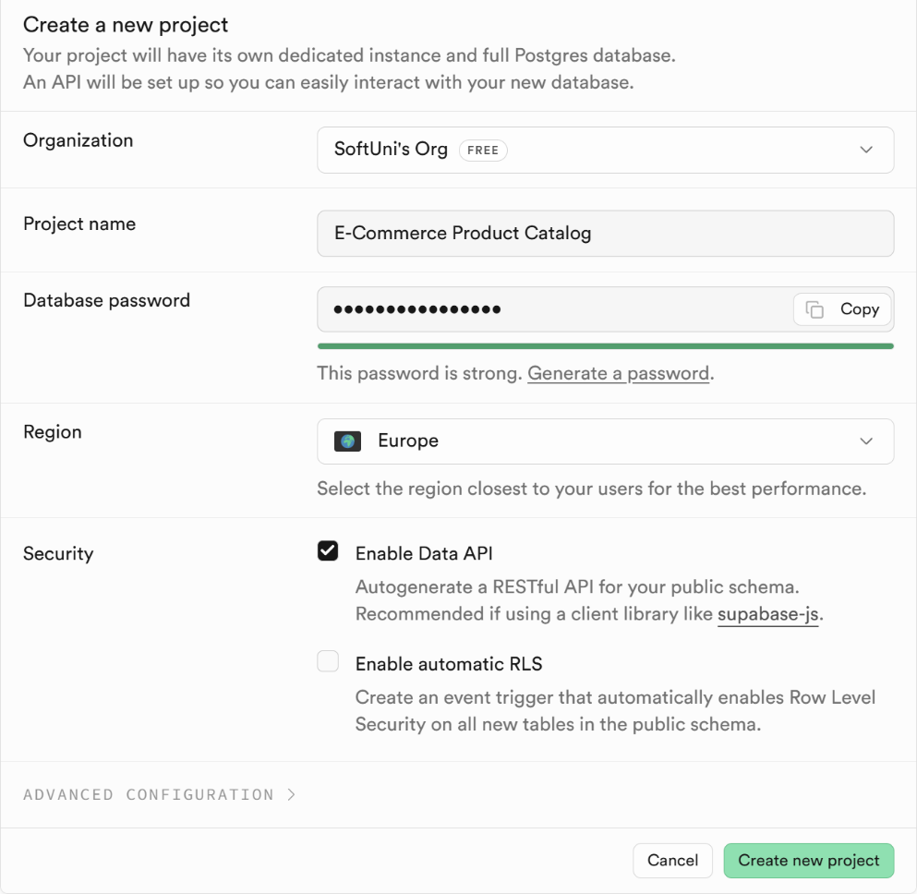

Install Supabase MCP
Go to your Dashboard in Supabase and select Connect, then the MCP tab. From the drop-down menu choose VS Code:
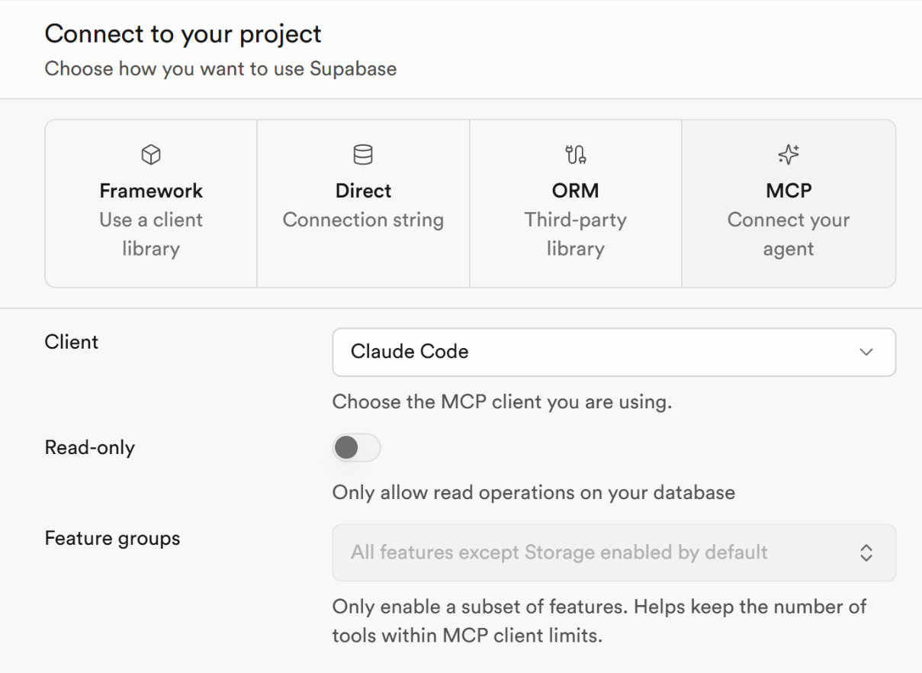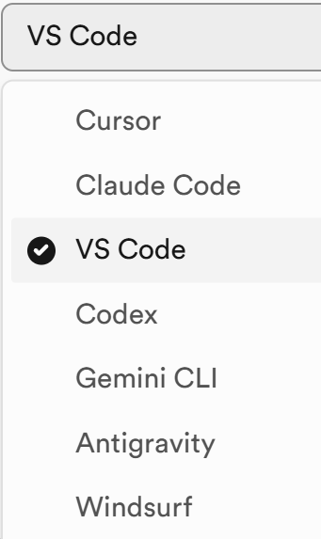
Press the [Add to VS Code] button:
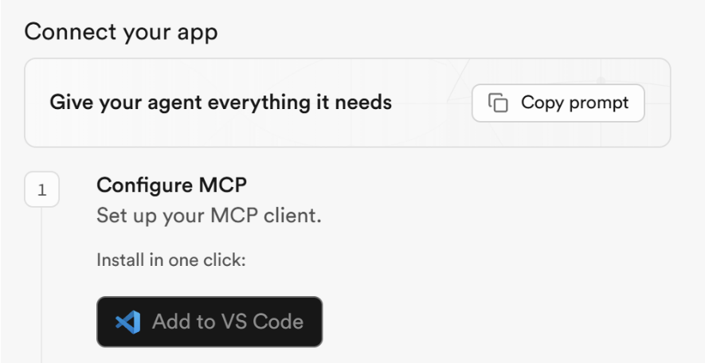
You will be forwarded to Visual Studio Code. Click the [Install in Workspace] button:
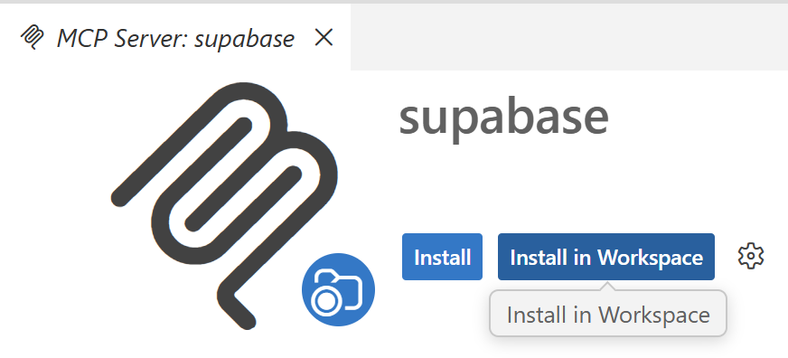
Click [Allow] for the following question:
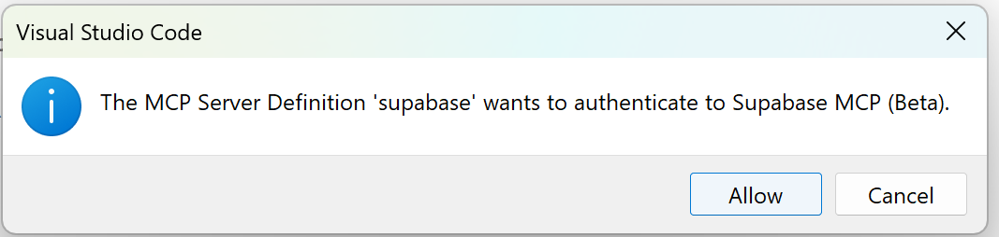
Authenticate the installed Supabase MCP server to your Supabase project. Select [Open]:
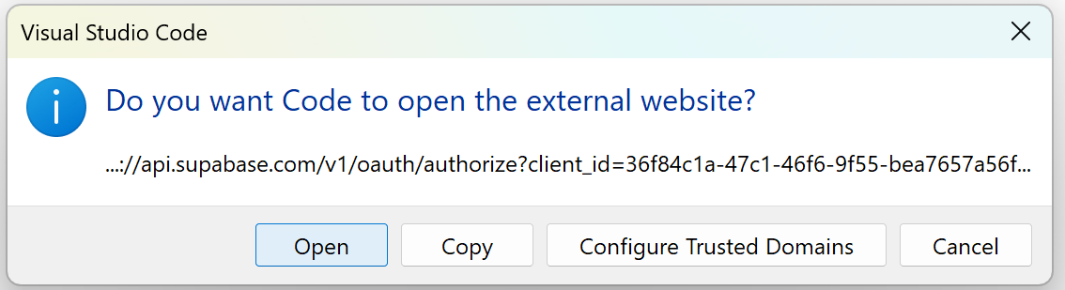
On the page that has opened, select [Authorize Visual Studio Code].

Check Supabase MCP
To check if Supabase MCP is running correctly, open the Chat window in VS Code (the GitHub Copilot chat) and click the settings button [Open Customizations]:
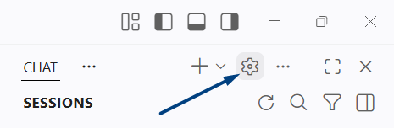
Choose [MCP Servers] tab to see which MCP servers are currently running.
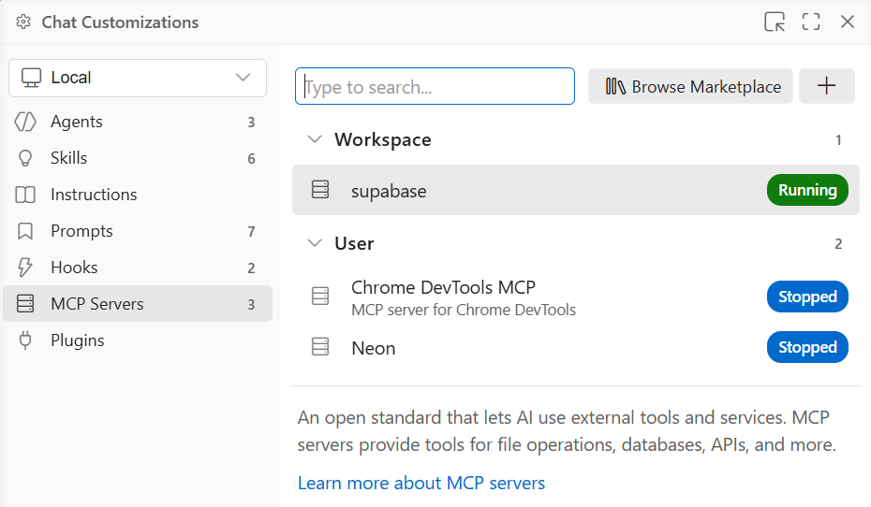
If "supabase" is shown as "Running", this means that Supabase MCP is properly configured, successfully connected to your Supabase project and works as expected.

Create DB Tables: AI Prompt
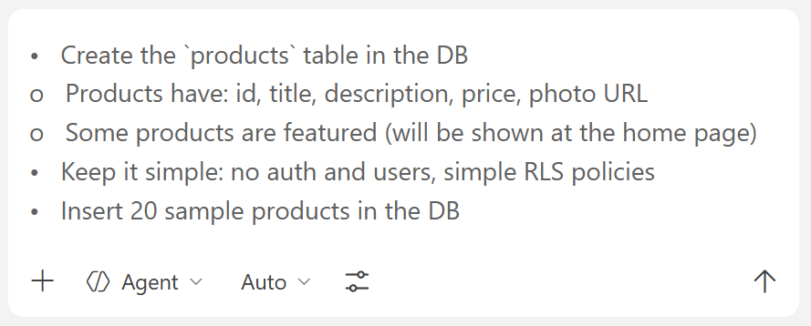

The Products Table in Supabase
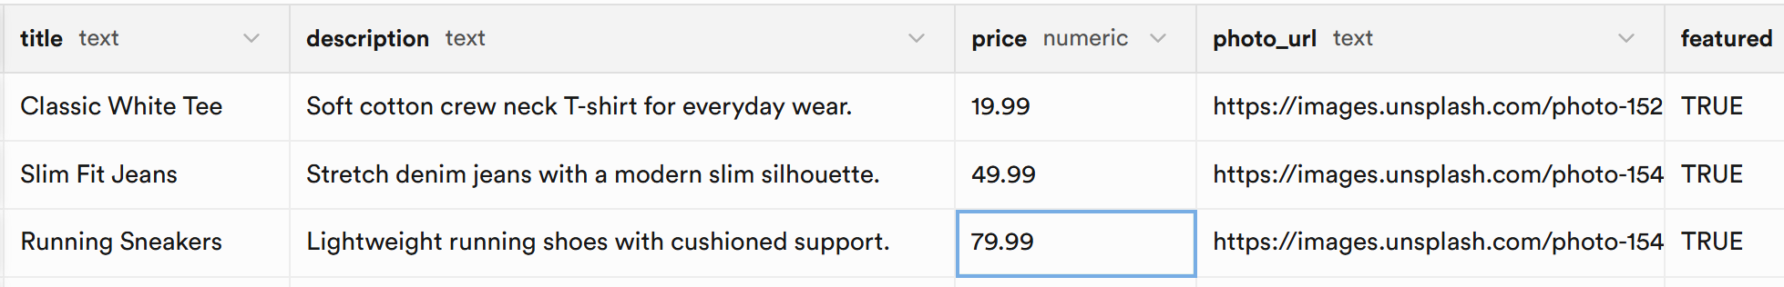

Step 4: Implement the App Functionality
- Implement the Home page: view welcome text + display the features products.
- Implement the Catalog page: view products as cards (with paging, 6 products per page) + search by keyword.
- Implement the Product Details page (view full product info).

Sample AI Prompt
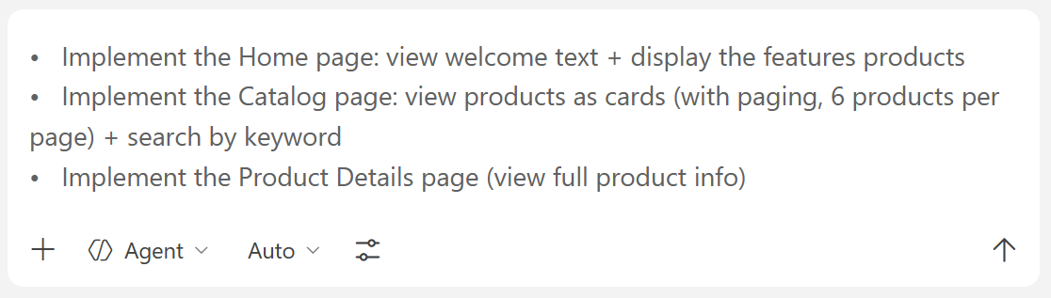

The App in the Browser
This is how your app's Home page may look like:
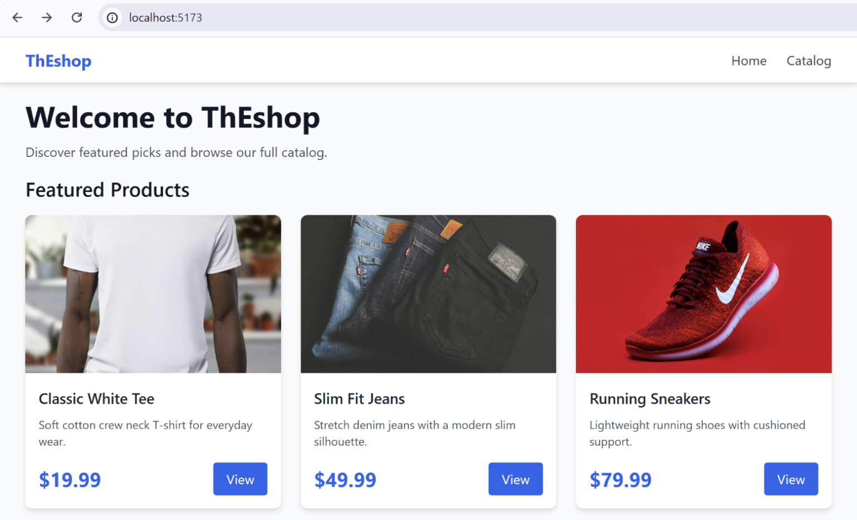

The Search and View Options
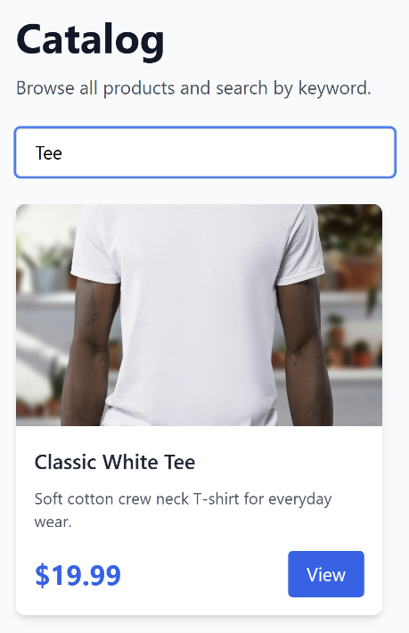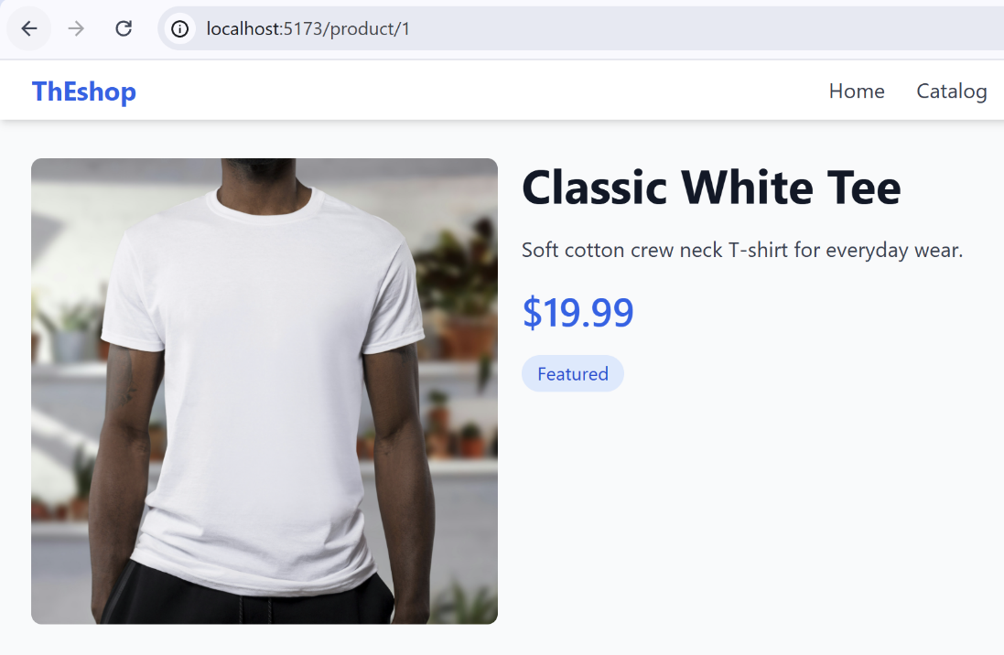

Listings Web Site
In this exercise we shall create a minimalistic listings web site (real estates for sale): visitors browse and view listings, users publish new listings / edit / delete own listings (after login). Implement it with React, Vite, TypeScript, Tailwind, React Router and Supabase (Auth + DB + Storage).
We shall build the app step by step, with multiple prompts, with a review of the produced result after each prompt.

Step 0. Create VS Project
Create a new workspace in VS Code for your app, e.g. `react-listings`.

Step 1. Setup Vite + React + Tailwind + React Router
- Initialize a Vite project with React + TypeScript
- Add Tailwind CSS and configure it with Vite
- Add React Router and configure app folders: src/pages/, src/components/, etc.
- Remove the default content, which comes from the React + Vite app template.

Sample AI Prompt
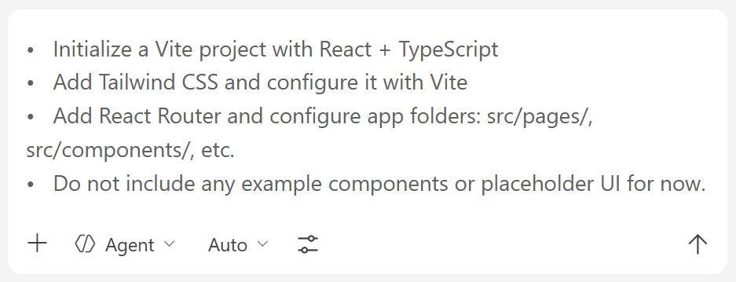

The Result
Like in the previous exercise, the AI chat has generated some empty folders, generic configuration files and default structure which will be filled with data in the next steps:
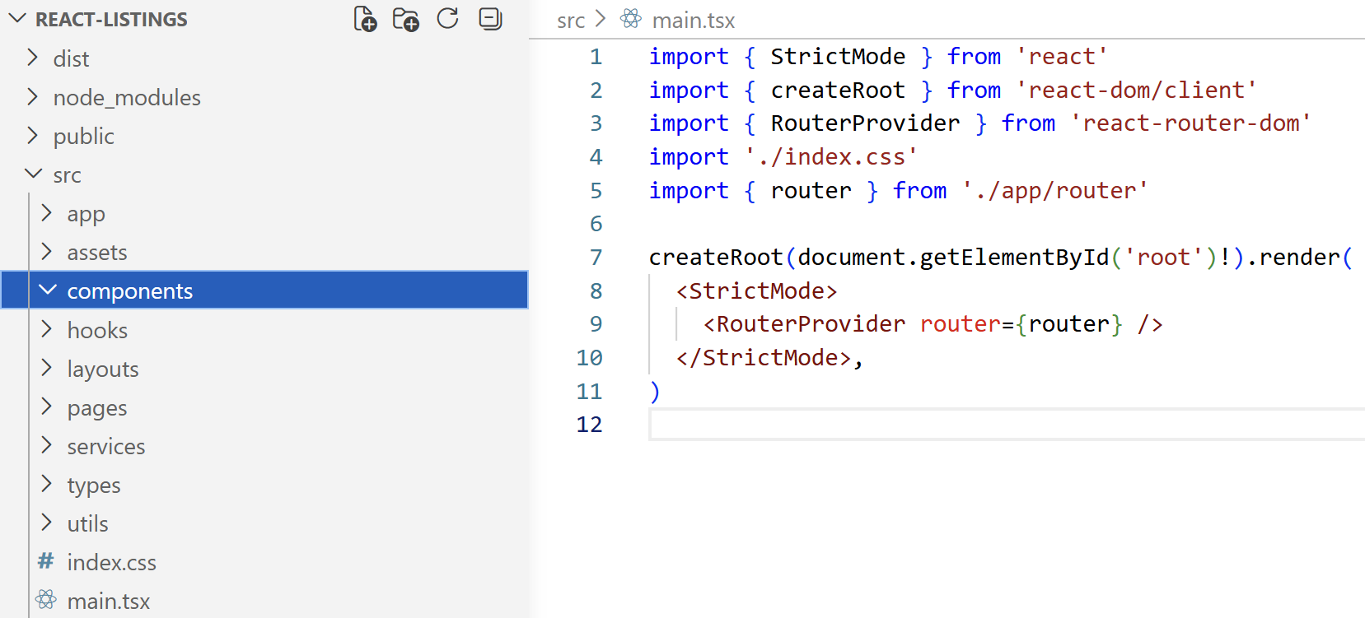

Step 2. App Pages, Layout and Navigation
- Configure React Router with the following pages:
  - Home (/) – welcome + latest listings preview
  - Browse Listings (/listings) – list + search + paging
  - Listing Details (/listing/:id) – full listing view
  - Login (/login), Register (/register)
  - My Listings (Dashboard) (/dashboard) – user’s own listings (protected route)
  - Create Listing (/dashboard/publish) – form (protected route)
  - Edit Listing (/dashboard/edit/:id) – form (protected route)
  - Delete Listing (/dashboard/delete/:id) – form (protected route)
- Implement empty pages + navigation between them
- Use shared reusable layout components:
  - Navbar (shows different actions when logged in/out) + Footer
- Build reusable listing UI components:
  - ListingCard component (title, price, small image, location, created at)
  - ProtectedRoute wrapper (redirect to /login if not logged in)

Sample AI Prompt
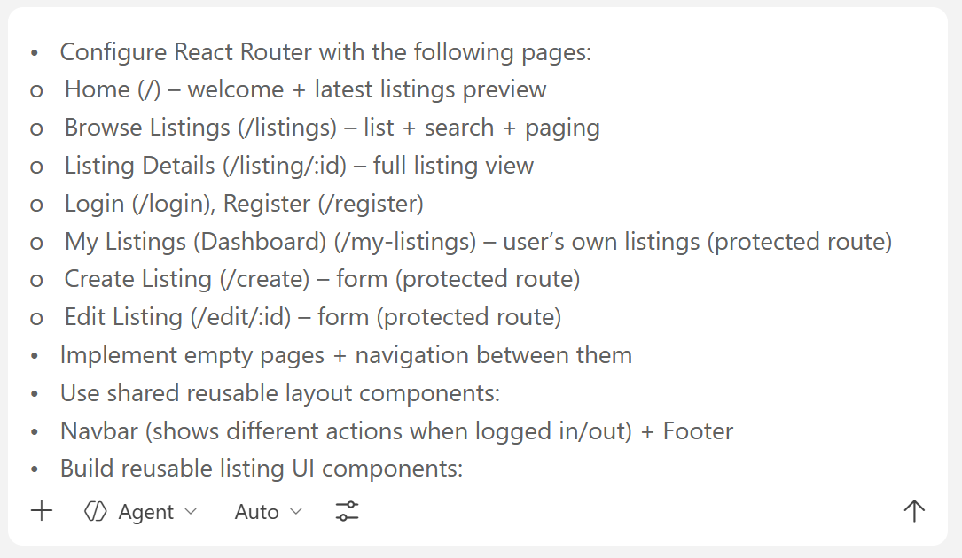

The Result
Here is how the generated app with empty pages may look like. The app implements generic layout and transitions between pages, which are empty (for now).

The Home Page
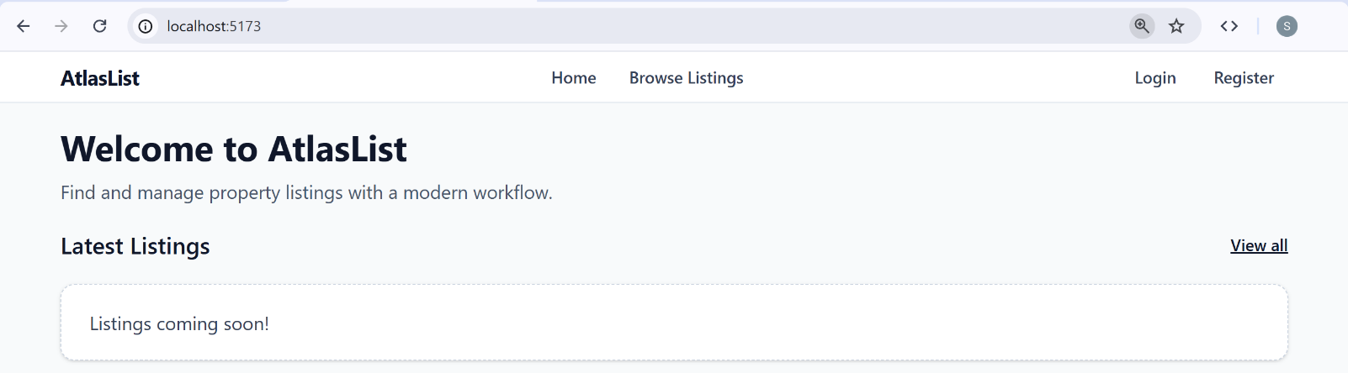

The Browsing Page
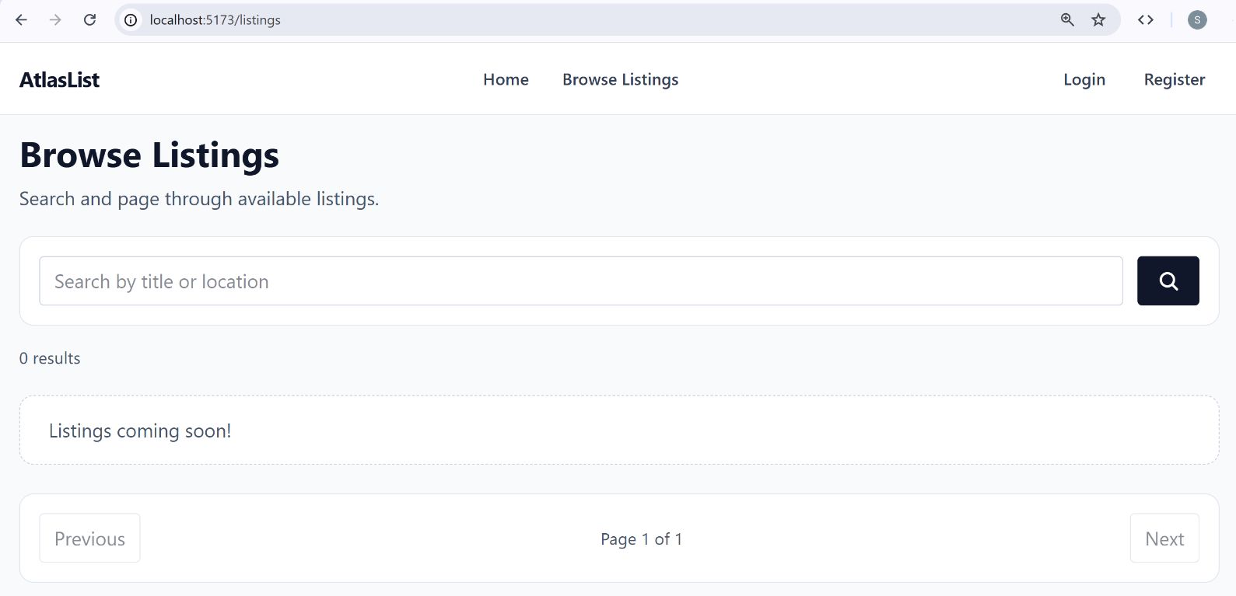

The Login / Register Pages
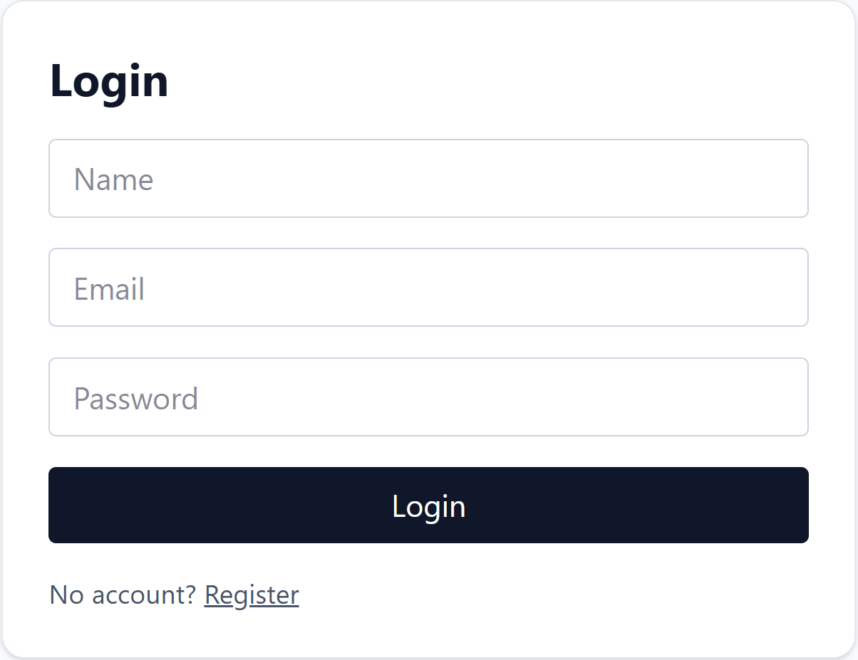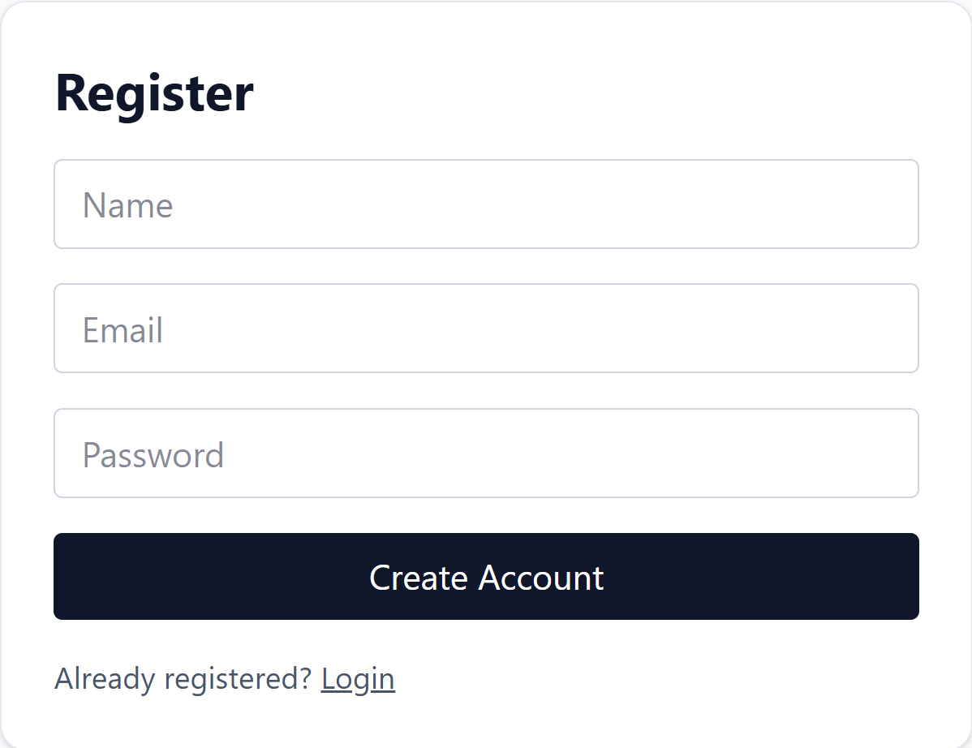

Step 3. Supabase Setup (Auth + DB + Storage)
- Create a Supabase project and connect it with VS Code using Supabase MCP
- Enable Supabase Auth (email + password), disable "confirm emails"
- Create DB table `user_profiles` (name, email, phone number)
- Create DB table `listings` (title, description, price, location)
- Define standard RLS policies: everyone can view listings, users manage their own listings
- Create a Supabase storage bucket `listing-photos` to hold the photos for listings
  - RLS policies: everyone can view photos, listing owners can add / edit / delete photos
- Define one-to-many table to connect listings with their photos: `listing_photos`
- Keep all DB migrations in a local folder, then apply them in the DB

Set Up a Supabase Project
Create a Supabase project and connect it with VS Code using Supabase MCP.
Enable Supabase Auth (email + password), disable "confirm emails". Select [Authentication] from the drop-down menu and then click [Sign In / Providers]:
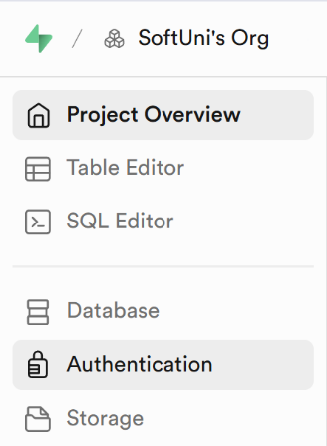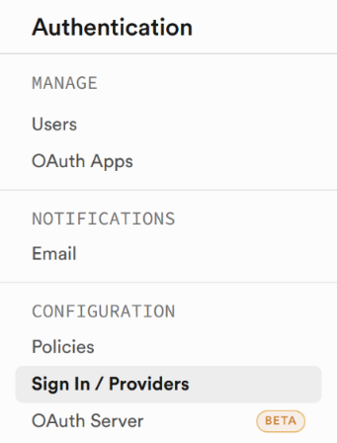
Make sure the "Confirm email" option is unchecked and click the [Save changes] button when done:
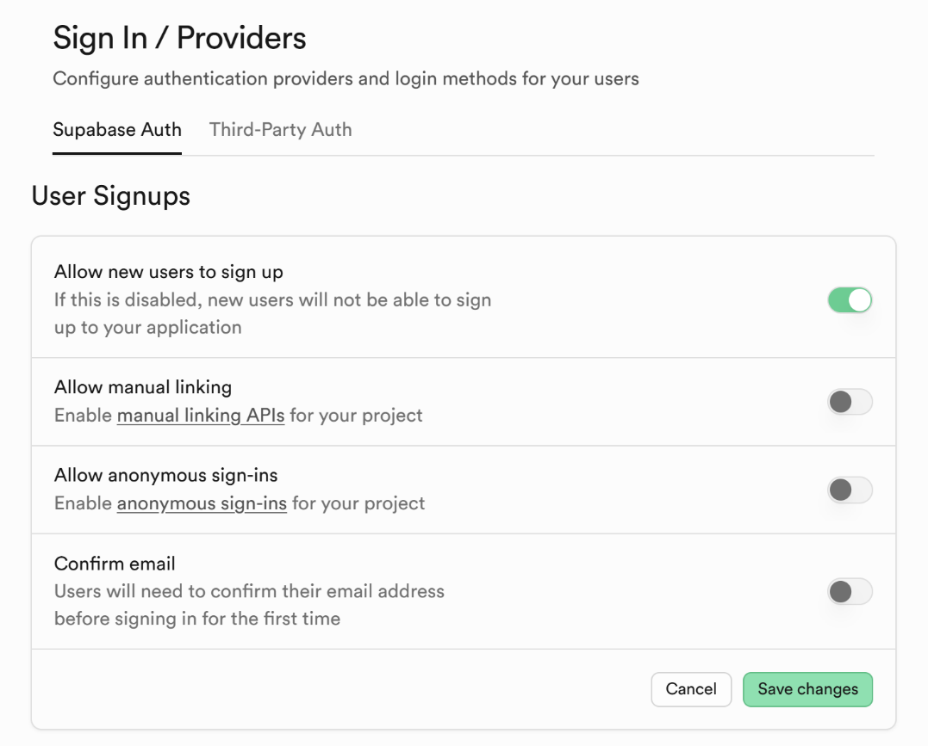

Create the Database Schema
Now run AI prompts in GitHub Copilot to create database tables in Supabase, configure RLS policies, and set up Supabase storage buckets.

Supabase DB Schema
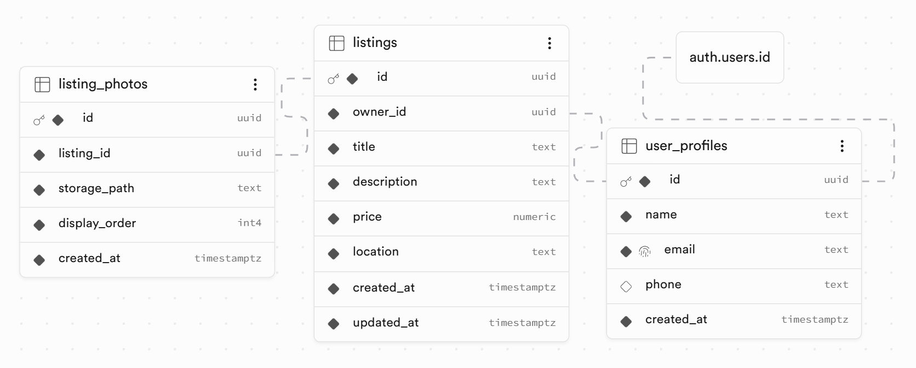

Step 4. Seed Sample Data in Supabase
We need sample data in the database for testing the app.
Create and run a JS script to seed sample data, using the Supabase client API:
- Create users: steve@gmail.com / pass123, maria@gmail.com / pass123
- Create 4-5 listings per user
- Insert 2-3 photos from Internet to the Supabase storage bucket for each listing
Note that running commands to fill sample data in GitHub Copilot will fail, because Supabase MCP does not support creating users. Instead of seeding sample data from GitHub Copilot, we will create and run a JS script, which will register users and seed sample data in the DB, using the Supabase client API.

Sample AI Prompt
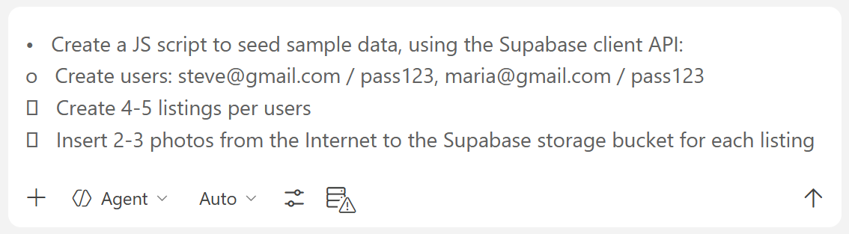

The DB Seeding Script
The generated JS DB seeding script file contains all the sample data that will be inserted in the database. This is how this script may look like:
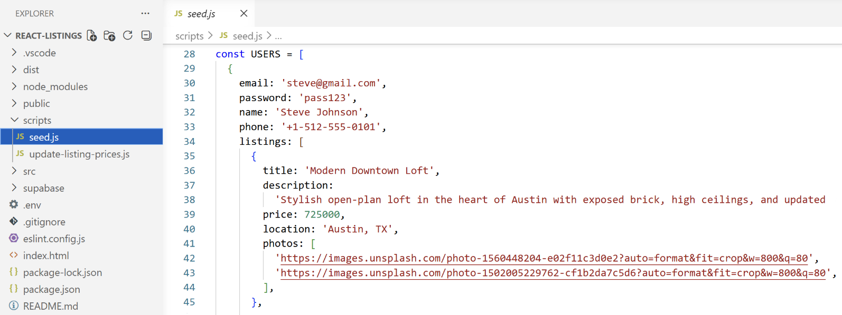

Step 5. Implement App Functionality
Now, it's time to implement the entire app logic:
- Create a modern dynamic UI to implement the listings app functionality
- Implement authentication (user register / login / logout)
- Home Page: display a welcome text + the last 6 listings
- Browse Listings page (/listings)
  - Show listings as cards with paging (6 per page)
  - Display the first photo as cover image
  - Implement a search box
- Listing Details page (/listing/:id)
  - Show full listing info: title, description, price, location, created date, seller contacts
  - Show product photos in an image slider
- My Listings page (/dashboard) (protected route)
  - Show listings as cards with actions: Edit | Delete
  - Edit button: go to /edit/:id
  - Delete button: go to /delete/:id -> confirm delete
  - Implement paging: 6 listings per page
- Create Listing page (/dashboard/publish) (protected route, for logged-in users only)
  - Standard form with multi file upload box
  - Create a listing and upload files after submit
  - Keep the new listing in the DB
  - Keep the uploaded photos in Supabase storage
- Edit Listing page (/dashboard/edit/:id) (protected route)
  - Standard form with multi file upload box
  - Modify the listing and upload / remove files after submitting
- Confirm Delete page (/dashboard/delete/:id) (protected route)
  - Confirm / reject delete for certain listing
  - Deleting a listing deletes also its uploaded photos

Sample AI Prompt
You can create each page with a separate prompt or try to implement all pages with a single prompt.
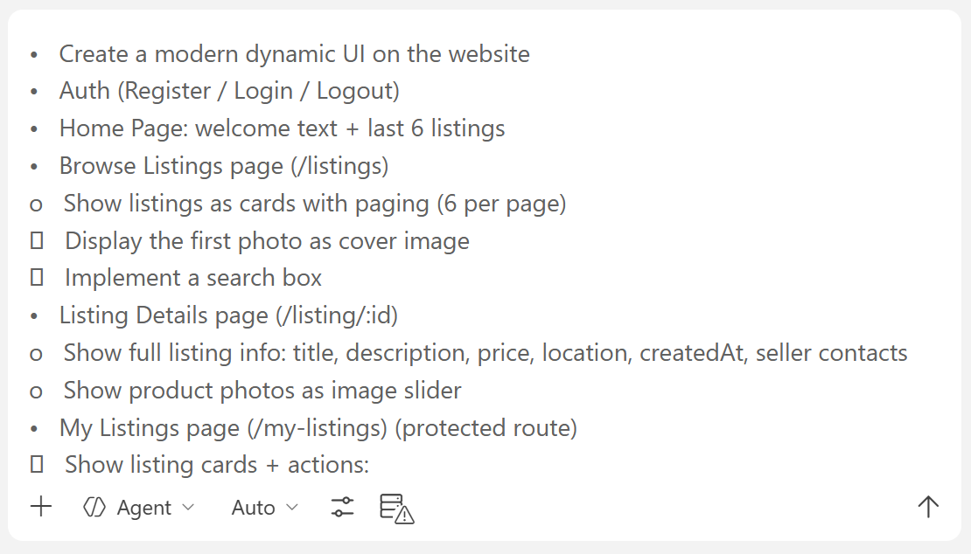

The Result
This is how the app pages may look like when implemented:

The Home Page
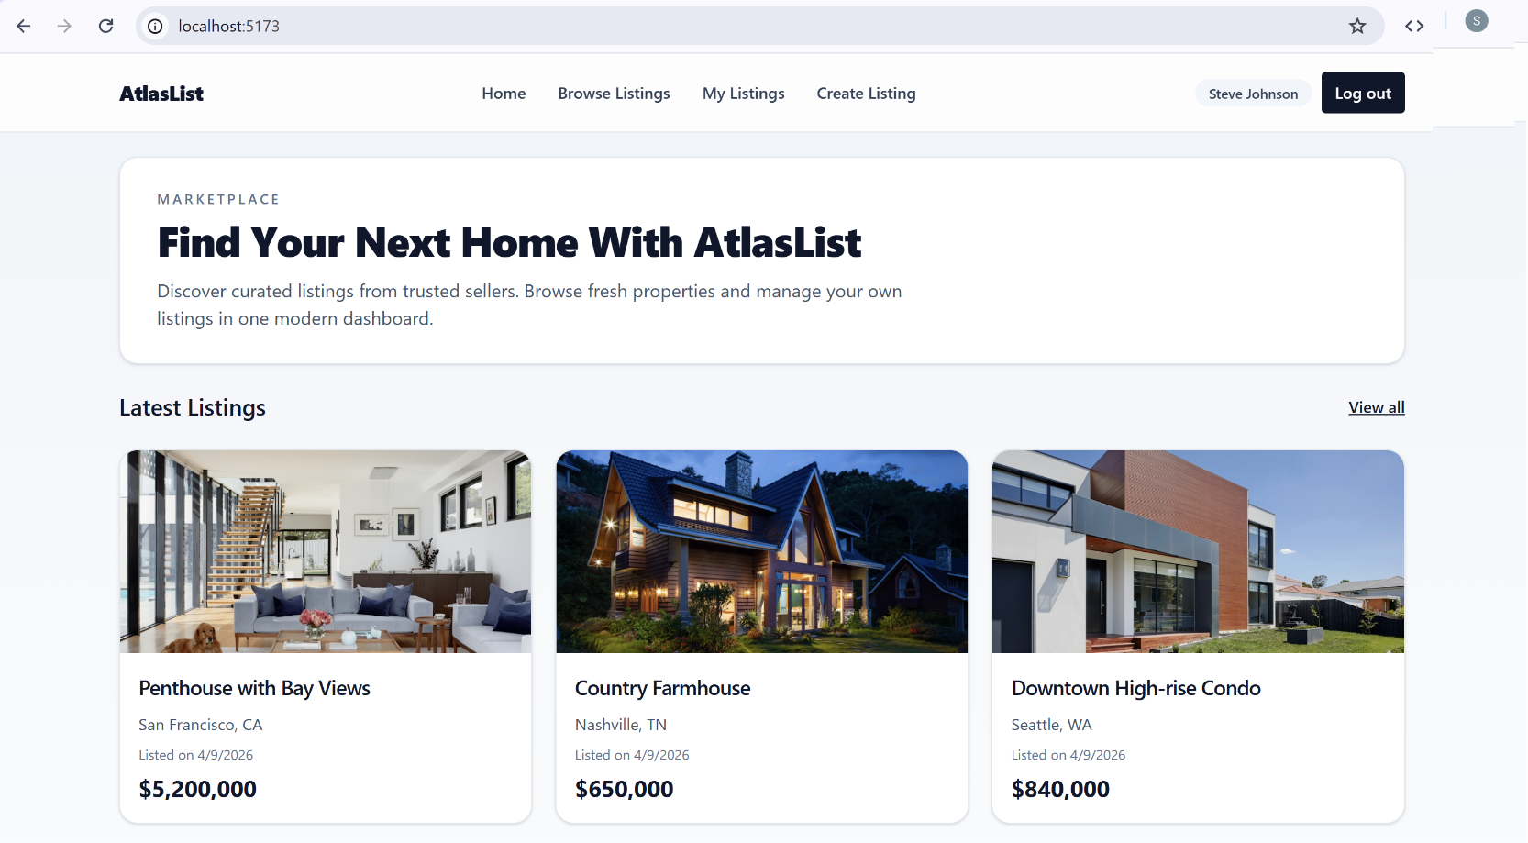

The Listings Page
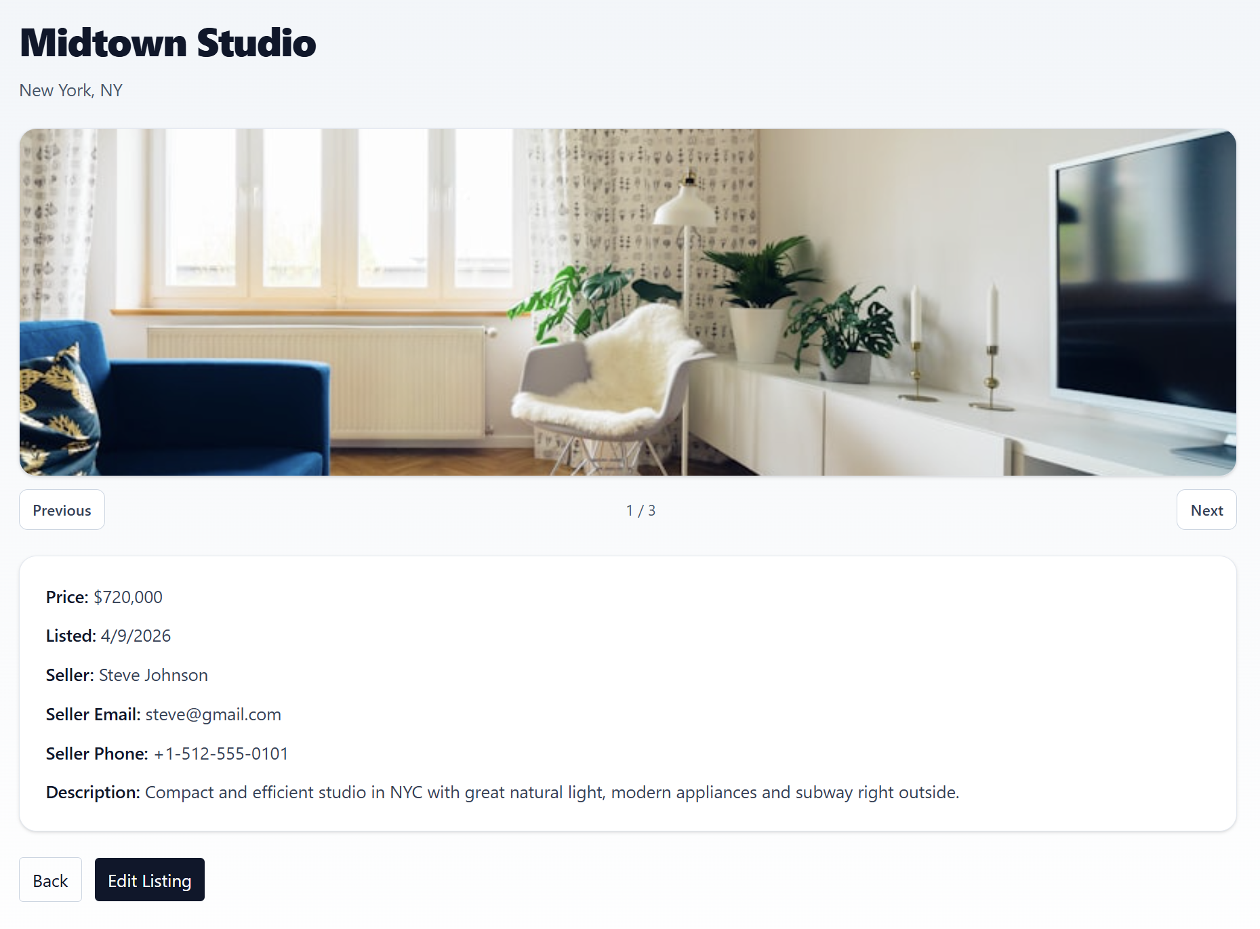

Editing a Listing
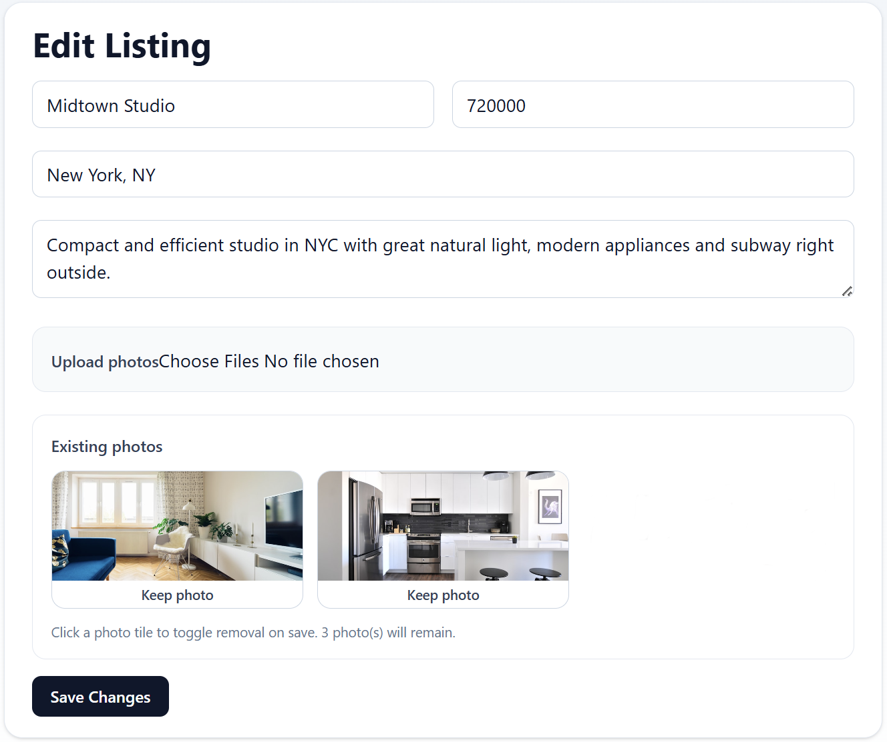

Creating a Listing
